Data Intake Gateway (DIG)

A Guide for Geotab Integrators

Revision History

|  |  |  |  |
| --- | --- | --- | --- |
| **Version** | **Date** | **DIG Version** | **Revision Comments** |
| 1.0.6 | July, 2021 | 1.0.4+ | Add content and diagrams to improve general concepts and address common questions. |
| 1.0.5 | June, 2021 | 1.0.4+ | Add additional records documentation for fault records. |
| 1.0.4 | June, 2021 | 1.0.0+ | Cleanup historical context section. Add additional records documentation to the record workflow appendix and enhance section description. |
| 1.0.3 | April, 2021 | 0.1.2+ | Add appendix to record workflow for record-specific context. Includes GpsRecord. |
| 1.0.2 | March, 2021 | 0.1.2+ | Add high-level diagrams. |
| 1.0.1 | February, 2021 | 0.1.2+ | Add GitHub reference to DIG OpenAPI YAML specification. |
| 1.0.0 | January, 2021 | 0.1.2+ | New document, initial release. |

* DIG Version: refers to the DIG software version that this document is applicable for (see [DIG Release Notes](https://docs.google.com/document/d/15ri-YS2nonQuyHTapbSVYOtkpveFx12izlHaPHEpOhE)).

**Table of Contents**

**Introduction 4**

Audience 4

Overview 4

Details 4

Historical Context 5

Suggested Reading 5

Terms and Definitions 5

**Getting Started 6**

MyAdmin User Roles 6

API Core Workflows 6

API References 7

Implementation 7

**Best Practices & Usage Expectations 8**

DIG API Workflow Best Practices 8

HTTP Response Codes 9

Testing New Integrations 9

**FAQs 9**

# Introduction

## Audience

This document aims to help Geotab integrators understand the Data Intake Gateway (DIG). It can be useful to anyone who is looking to integrate their custom telematics devices into MyGeotab.

## Overview

This document describes how Geotab provides support for the integration of Custom Telematics Devices. These devices are defined as any telematics device that is not manufactured or sold by Geotab but is used in conjunction with Geotab’s fleet management application.

Integrating a Custom Telematics Device with Geotab requires the use of the Data Intake Gateway.

[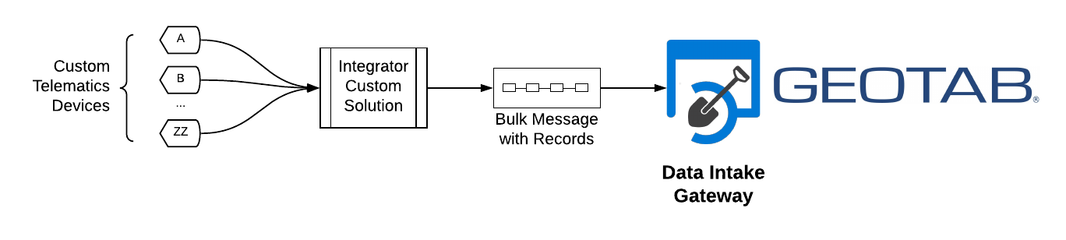](https://lucid.app/documents/edit/429a1810-db33-456c-95f1-9ab6c05bd10f/4?callback=close&name=docs&callback_type=back&v=4199&s=684)

|  |
| --- |
| **✱ NOTE:** The solution is not intended to support devices direct-to-DIG and requires system integration for bulking records from custom telematics devices into bulk requests to DIG. |

See the [Custom Telematics Devices and MyGeotab](https://docs.google.com/document/d/1Mddnxc2qKBCNYvVu0-BXcyR-blPlHwa0Zun0mBzZt88) document for a high-level overview of the registration process or contact your Reseller for more information about obtaining a MyAdmin account.

## Details

The Data Intake Gateway accepts bulk requests containing custom telematics’ device records to an HTTPS REST endpoint. The DIG advantages include:

* **Data integrity**: guarantees no data loss once accepted.
* **API**: provides a RESTful interface.
* **Authentication and Authorization**: leverages [JWT](https://jwt.io/), considered robust and secure.
* **Performance**: enables direct API request using “Fast-ACK” with HTTP 202 ACCEPTED responses.
* **Resiliency**: offers industry-leading cloud, technology, and architecture designed from the ground up to survive self and dependent system maintenance and outages.
* **Scalability**: adapts easily to customer growth over time.

The diagram below illustrates the integration architecture.

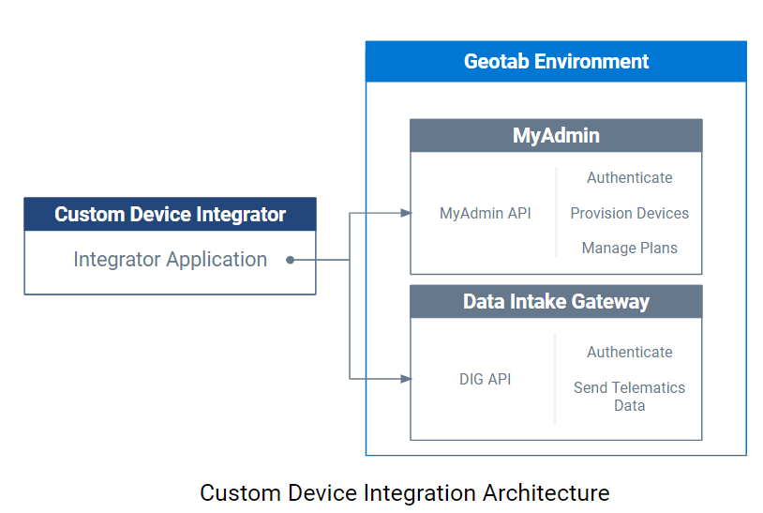

## Historical Context

DIG is the Geotab standard for sending custom telematics data [introduced in early 2021](https://docs.google.com/document/d/1FGADvkJSEMyd1jGj3KHmhcLNfQYBpq1LMDwzptGS9MU). The solution replaces and supersedes a portion of the MyAdmin API/SDK that deals with sending records (legacy term Third-Party Records) into the Geotab platform.

For general understanding and historical reference on the subject, you can read the following pages:

* [Geotab MyAdmin API](https://myadmin.geotab.com/sdk/api/apiReference.html)
* [MyGeotab SDK](https://geotab.github.io/sdk/software/api/reference/)

|  |
| --- |
| **✱ NOTE:** Some referenced links may confound and conflict with the new solution until they have been updated. |

## Suggested Reading

Before getting started with DIG, we recommend that you read the following resources:

* [Using Third-Party Devices with MyGeotab](https://myadmin.geotab.com/sdk/pages/third-party.html)
* [MyGeotab SDK](https://geotab.github.io/sdk/software/guides/concepts/#unit-of-measure)
  + [Unit of Measure](https://geotab.github.io/sdk/software/guides/concepts/#unit-of-measure)
  + [Working with Dates](https://geotab.github.io/sdk/software/guides/concepts/#unit-of-measure)

## Terms and Definitions

|  |  |
| --- | --- |
| **Term** | **Definition** |
| Custom Telematics Device | Any device that is not a [Geotab GO Device](https://www.geotab.com/vehicle-tracking-device/) but is used in conjunction with Geotab’s fleet management platform and is capable of providing its own positional (e.g. GPS) data. |
| Record(s) | Contains context-specific information for a specific device. Usually associated with a specific point in time as a snapshot of data. All records for DIG are considered Custom Telematics Device Records and these terms are used interchangeably. |
| Custom Telematics Device Record(s) | Data records from custom telematics devices. There are numerous types of records and so the content within each record is contextual to the record type itself. |
| DIG API Authentication Endpoints | API requests that deal specifically with authentication and token management as it applies to DIG (e.g. Authenticate, Refresh Token and Revoke Token). |
| DIG API Functional Endpoints | Non-authentication related DIG endpoints (e.g. POST Records or GET Invalid Records). |
| MyAdmin User Account | The account used to authenticate with DIG via the authentication endpoints. It must be a MyAdmin account set with the appropriate type and roles to utilize DIG. |

# Getting Started

## MyAdmin User Roles

To authenticate and leverage DIG services your MyAdmin service account must have the **DIG-Access** role. For failed authentication or authorization issues please contact [Geotab Support](https://myadmin.geotab.com/helpdesk). For more information, see the “Integration Overview” section in [Custom Telematics Devices and MyGeotab](https://docs.google.com/document/d/1Mddnxc2qKBCNYvVu0-BXcyR-blPlHwa0Zun0mBzZt88).

## API Core Workflows

The diagram below illustrates a high-level DIG integration:

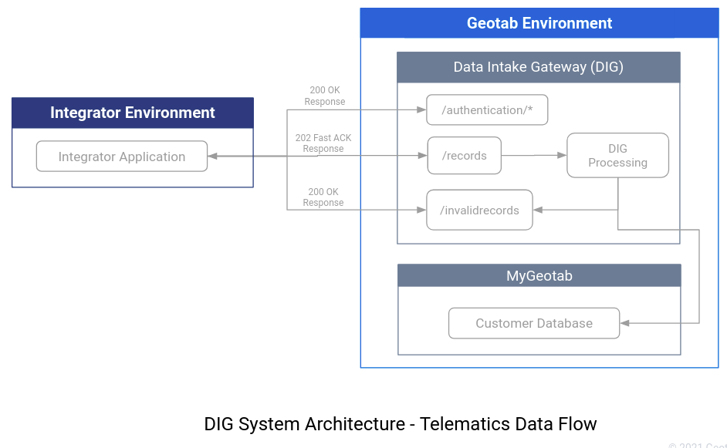

See the following references for details:

* **/authentication/\*\*\*** = authentication and token management  
  See [DIG API Authentication Workflow](https://docs.google.com/document/d/1aRPIDz7d49BEqEID_ZLjtrhwAuHacWO1WhTMUVUXwMI/)
* **/records** = POST custom telematics device records  
  **/invalidrecords** = GET invalid records  
  See [DIG API Endpoint Workflow](https://docs.google.com/document/d/1XFHQ1s-um6HcW3qPRNiKX7bj-_X-O--4Fj4_j_An8U0)

## API References

* Open API YAML Specification: **[data-intake-gateway-api.yaml](https://github.com/Geotab/data-intake-gateway/blob/develop/data-intake-gateway-api.yaml)**

## Implementation

If you are interested in a code bootstrap for your programming language of choice, we recommend using Swagger’s auto-generate “Codegen” feature from DIG’s Open API YAML specification on GitHub.

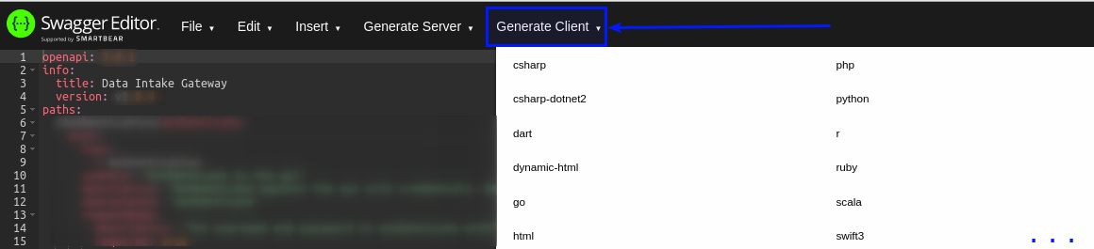

See the Generate Client dropdown, which lists all the supported languages.

|  |
| --- |
| **✱ NOTE:** This is a great way to start generating sample direct DIG API requests and response parsing in a given programming language. However, it does not write your implementation for you within the proper DIG API Workflows for your integration and business requirements. |

# Best Practices & Usage Expectations

## DIG API Workflow Best Practices

We recommend that you familiarize yourself with best practices and usage pattern expectations for the solution.

* See [DIG API Authentication Workflow](https://docs.google.com/document/d/1aRPIDz7d49BEqEID_ZLjtrhwAuHacWO1WhTMUVUXwMI/) for information on authentication and token management.
* See [DIG API Endpoint Workflow](https://docs.google.com/document/d/1XFHQ1s-um6HcW3qPRNiKX7bj-_X-O--4Fj4_j_An8U0) for more information on general API endpoints including /records and /invalidrecords.

After you have read the information above, see the following high-level diagram to understand the separate components of a typical DIG integration:

[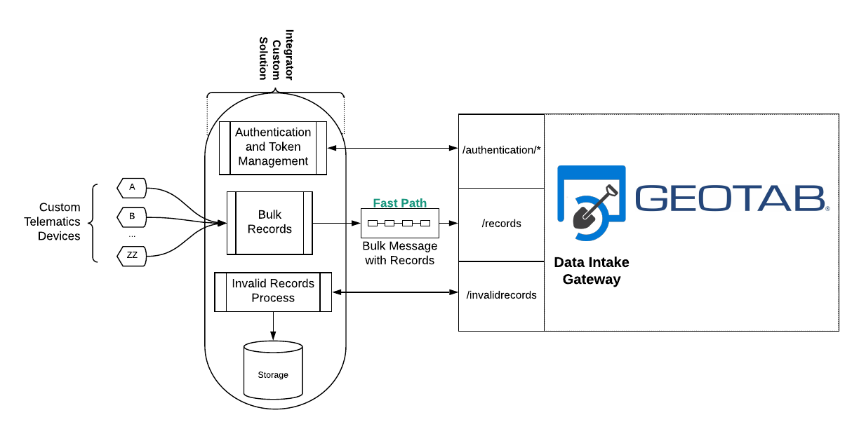](https://lucid.app/documents/edit/429a1810-db33-456c-95f1-9ab6c05bd10f/5?callback=close&name=docs&callback_type=back&v=4199&s=612)

## HTTP Response Codes

DIG uses standard HTTP status codes for request responses. System integrators should take care to properly handle these. Requests that return HTTP response codes such as the following should not typically be retried:

* **2xx = OK or ACCEPTED**
* **400 = BAD_REQUEST**
* **401/403 = UNAUTHORIZED or FORBIDDEN**

Typically, other response statuses may need to be retried. For example, some endpoints or scenarios may return **503 SERVICE_UNAVAILABLE**, which should be retried. The aforementioned DIG API workflow reference documents fully describe expectations in more detail in context to the endpoint.

## Testing New Integrations

Integrators are free to use the production DIG endpoint for testing under the following recommendations:

* Limit to simple experimentation and basic integration implementation validation.
* Use fake custom device serial numbers for early phase API endpoint testing (valid records for these devices will become invalid records if the serial number is not valid). Sending valid records for real devices will end up in MyGeotab.

If you desire to test end-to-end to a MyGeotab database without billing implications, please contact [integrations@geotab.com](mailto:integrations@geotab.com) to request temporary test devices.

# FAQs

**Which Geotab Support channel should I engage with if I am experiencing issues with DIG?**

MyAdmin Support Ticket. For any production inquiries or issues, please submit a [support ticket](https://myadmin.geotab.com/helpdesk) through MyAdmin.

Integration Solutions and Development. For any integration questions while developing custom solutions with DIG, please reach out to **[integrations@geotab.com](mailto:integrations@geotab.com)**.

**Where does DIG send the record data to?**

MyGeotab. All valid records are delivered to the correct MyGeotab database(s) according to device ownership and any other relevant account or device configurations.

**How quickly does custom telematics data accepted by DIG get processed?**

As quickly as possible. Due to varying load conditions, Geotab cannot provide any hard time guarantee for how quickly data accepted into DIG will ultimately end up in the target MyGeotab database(s). Customers can rest assured that data is processed on high-performance infrastructure and becomes available promptly with minimal latency.

**How quickly are records marked as valid or invalid?**

This determination is made as quickly as possible. Due to multiple variables within the system and multiple reasons for records to be marked as invalid, Geotab cannot provide a hard time guarantee. If a request to **/records** is accepted (202), your high-performance integration can assume the data was accepted. The **/invalidrecords** workflow can be periodically queried to determine if any records were subsequently marked as invalid and need attention. See the [DIG API Endpoint Workflow Guide](https://docs.google.com/document/d/1XFHQ1s-um6HcW3qPRNiKX7bj-_X-O--4Fj4_j_An8U0) for additional detail and recommendations.

**What are some potential reasons for records to be marked as invalid, and what is the expected correction?**

Geotab recommends that all invalid records are stored for manual inspection and case-by-case assessment before resending or discarding. There are many reasons why a record may subsequently be marked as invalid. The system assesses validity in multiple stages. The most common reasons include, but are not limited to:

* **Invalid Serial Number**: sending a record for a device that is invalid, unprovisioned, not active, or not owned by your account.
* **Missing Mandatory Data Field**:some record fields are mandatory.
* **Bad or Corrupt Data**: some record types have data value validations and restrictions per industry specification, DIG API specification, or some other requirement; additionally, some data types require a specific encoding.

All scenarios must have some action performed and a decision about whether to retry the data. Actions may include finishing administrative tasks (billing, device provisioning), correcting corrupt data from devices at the source, fixing issues in implementation’s data processing, etc., before retrying. A final decision to discard the data may also be the outcome, but it depends on your business requirements.

**Is there additional documentation for the Geotab custom telematics device record types?**

Yes. In addition to the API reference specification provided above, see the [Custom Telematics Device Records](https://docs.google.com/document/d/1XFHQ1s-um6HcW3qPRNiKX7bj-_X-O--4Fj4_j_An8U0/edit#heading=h.cvx7jvdttg20) section in the **Appendix** of the [DIG API Endpoint Workflow Guide](https://docs.google.com/document/d/1XFHQ1s-um6HcW3qPRNiKX7bj-_X-O--4Fj4_j_An8U0).